EMOTIONAL INTELLIGENCE NOT INCLUDED
- Intelligence: The ability to act purposefully, think logically, and handle the environment effectively.
  - Example: Solving a complex problem under pressure during a project deadline.
- IQ (Intelligence Quotient): Measures a person’s reasoning ability—problem-solving, memory, and logic.
  - Example: Someone with high IQ might be great at coding or winning at logic-based games.
- Intelligence predicts academic and job success but doesn't guarantee success in life. Emotional and social factors matter too.

What Are Emotions?
- Emotions are subjective experiences that automatically occur in response to stimuli.
- They affect physical and psychological states, which in turn influence our behavior.
Key Facts:
- Emotions are short-lived but can influence longer-term moods.
- Emotions can be mild, intense, or anywhere in between. The intensity of an emotion can depend on the situation and on the person.
- There are no universally “good” or “bad” emotions—it’s how we handle them that matters.
- Suppressing emotions may cause physical stress.
  - Example: Bottling up anger might lead to increased blood pressure.

Why Are Emotions Important?
- Emotions help build and maintain relationships.
- They signal danger and aid in survival.
- They allow empathy and understanding in social interactions with others and vice versa.
  - Example: Without fear, we may take reckless risks. Without joy, social bonding is harder.
  - Ted Bundy, who had antisocial personality disorder, showed no fear or empathy—highlighting the role emotions play in moral behavior.

What is Emotional Intelligence (EQ)?
- EQ refers to recognizing, understanding, managing, and using emotions effectively—both our own and others’.
  - Example: Comforting a friend instead of becoming frustrated at their mood shows high EQ.
EQ vs. IQ
- EQ contributes more to long-term success than IQ, IQ only accounts for 20%.
  - “IQ gets you hired, but lack of EQ gets you fired.”
- Darwin noted that adaptability—not intelligence or strength—is key to survival.
  - Example: A flexible, emotionally aware employee handles workplace changes better than a rigid genius.
4 Components of Emotional Intelligence
- Self-Awareness
  - Recognizing your emotions and how they affect your thoughts and actions.
  - Knowing your strengths, weaknesses, traits, and behvaiours
  - Improves self-control and decision-making.
  - Example: Realizing you're irritated before responding harshly in a meeting.
  - Develop through journaling, meditation, personality/psychometric tests, and reflection/monitoring
- Self-Management (Self-Regulation)
  - Handling emotions responsibly instead of reacting impulsively.
  - Example: Pausing before replying angrily in a disagreement.
  - Develop by acknowledging emotions, pausing, and choosing appropriate responses.
- Social Awareness (Empathy)
  - Understanding others’ emotions and perspectives.
  - Example: Noticing a friend is upset even without verbal cues.
  - Develop by listening actively, imagining others' experiences, be willing to share your feelings, and engaging in service.
- Social Skills (Relationship Management)
  - Managing relationships, resolving conflict, and communicating effectively.
  - Example: Calming a tense situation between team members.
  - Develop by making eye contact, observing non-verbal behavior, and taking interest in others.
Why Emotional Intelligence Skills Are Important
- Enhances Leadership
EQ helps leaders inspire, guide, and manage others effectively.
Example: A leader stays calm and supportive during a crisis.
- Improves Communication
Understanding others' emotions leads to clearer, more empathetic interactions.
Example: You notice frustration in a teammate and adjust your tone accordingly.
- Boosts Self-Awareness
Recognizing your emotions helps you understand your thoughts, behaviors, and triggers.
Example: You identify stress early and take steps to manage it.
- Strengthens Self-Control
EQ helps regulate emotional responses, avoiding impulsive reactions.
Example: Instead of lashing out, you pause and respond calmly in conflict.
- Supports Stress & Conflict Management
Better emotion regulation leads to more effective handling of pressure and disagreements.
Example: During a heated debate, you keep your composure and find common ground.
ATTITUDES NOT INCLUDED
Attitude: A learned predisposition to evaluate people, objects, or ideas positively or negatively. Example: A person may dislike fast food because they believe it’s unhealthy.

Key Characteristics
- Attitudes are stable but can change.
- They influence our emotions, thoughts, and actions.
  - Example: A positive attitude toward education motivates regular study.
- Help predict behavior in real-life contexts.
  - Example: Political beliefs influence voting behavior.

Three Components of Attitudes (ABC Model)
- Affective (Emotional): Emotional response or feelings toward something.
  - Example: “I hate exams” shows an emotional dislike.
- Behavioral (Action-related): How your attitude influences actions or behavior.
  - Example: Skipping classes because you dislike exams.
- Cognitive (Thought-based): Thoughts, beliefs, or knowledge about a person, object, or issue.
  - Example: Believing exams are unfair or cause stress.

How Attitudes Change
- Cognitive Dissonance (Festinger, 1957)
  - When behavior and belief conflict, discomfort arises.
  - Example: Smoking while believing it's unhealthy creates dissonance; the person may quit or justify it by saying “It’s not that bad.”
- Persuasion
  - A message influences attitude change.
  - Example: An anti-smoking ad uses emotional stories and facts to discourage smoking.
- Conformity
  - Adopting attitudes to match group norms.
  - Example: Someone who does not know the answer to a question ends up saying what the rest of the crowd says due to lack of knowledge.
  - Types:
    - Normative Conformity: To be liked. Example: Laughing at a joke you don't find funny to fit in.
    - Informational Conformity: Believing others know better. Example: Agreeing with peers’ opinions during a discussion even if unsure.
    - Solomon Asch Experiment: 50 male students were influenced by confederates giving wrong answers during a line length test to observe if they would conform.
- Compliance:
  - Changing behavior due to a request.
  - Example: Donating to a fundraiser after being asked.
- Obedience:
  - Obedience as a form of social influence elicited in response to direct orders from an authority figure
  - Example: A junior employee follows a senior manager’s directive, even if unsure.
- Prejudice (Prejudgment): Negative emotional feelings toward a group.
  - Example: Disliking someone just because of their race or religion.
- Discrimination: Unjust actions against a group targetted by prejudice
  - Example: Refusing to rent an apartment to someone based on ethnicity.
- Stereotypes: Fixed ideas or assumptions about a group.
  - Example: Believing all teenagers are irresponsible. / gender stereotypes
PERSONALITY
Personality: A consistent set of emotional, thought, and behavior patterns unique to an individual.
Originates from Latin word “persona,” meaning a mask. Personality is shaped by both genetics and life experiences, making each person unique. It influences our choices, how we act, and how others perceive us, including in behaviors like trolling.
Example: Someone may be consistently cheerful and dependable in all settings.

Theories of Personality
Psychoanalytic Theory (Freud): Personality stems from unconscious drives and childhood experiences.
Levels of Mind:
- Conscious – Current awareness
- Preconscious – Memories, stored knowledge
- Unconscious – Fears, desires, past trauma
Structure of Personality:
Structure | Description | Principle | Example
Id | Instincts, urges (selfish and pleasure seeking), what we are born with | Pleasure principle | Hamnah drinks from someone else's glass immediately
Ego | Rational, reality-based, involves decision-making, balances Id and Superego, develops in the next 3 years | Reality principle | Hamnah waits for the server to refill her water
Superego | Moral and ethical values, upholds societal values, develops around the age of 5 | Moral principle | Hamnah believes it’s wrong to drink from someone else’s glass
Example: A child wants to grab a toy (Id), decides to ask nicely (Ego), and avoids stealing it because it's wrong (Superego).
- Healthy personality: Strong ego that mediates between id and superego.
- Unhealthy personality: Over-dominant id (selfishness, crime) or superego (rigid morals).
A defense mechanism is an unconscious psychological process that protects an individual from anxiety-inducing thoughts and feelings stemming from internal conflicts and external stressors.
Defense Mechanism | Description | Example
Denial | Refusing to accept reality | Ignoring a cancer diagnosis
Displacement | Redirecting feelings to a safer target | Yelling at spouse after work stress
Projection | Attributing your own flaws to others | Accusing someone of being stupid in a debate
Regression | Reverting to childlike behaviors | Thumb sucking under stress
Repression | Blocking painful memories | Forgetting childhood trauma
Sublimation | Channeling urges into acceptable activities | Aggressive person becomes a boxer
Rationalization | Justifying failures or bad behavior | Blaming the teacher for failing
Humor | Making jokes in serious situations | Joking before surgery
Suppression | Voluntarily pushing away painful thoughts | Avoiding exam discussion
Social Learning Theories
(1) Behaviorism: A theory stating that a person’s behavior results from past rewards and punishments.
- Applied to personality: People differ in personality because they’ve experienced different reinforcement patterns, leading to reinforced behaviors.
- Example: A person whose parents laughed at her jokes may grow up to be humorous. Another person whose parents ignored her jokes may not develop that trait.
(2) Albert Bandura’s Social Learning Theory (SLT): An extension of behaviorism. Suggests behavior is learned not only through personal experience, but also by observing and imitating others.
- Adds that behaviour is also influenced by:
  - Observed behaviors
  - Reinforcements and punishments experienced by others
  - Interpretation of those reinforcements
  - Vicarious reinforcement: Learning by observing someone else being rewarded or punished.
- Example: A child who sees their sibling being praised for helping may imitate that behavior to gain similar praise.

Humanistic Approach — Carl Rogers
Person-Centered Theory
- People are inherently good and creative
- Every individual has the potential to grow and fulfill their true self
- People are free to choose and determine their own lives
Quote: “The curious paradox is that when I accept myself just as I am, then I can change.” – Carl Rogers
Conditions for Growth (Necessary Environment)
- Genuineness: Openness, honesty, and self-disclosure
- Acceptance / Unconditional Positive Regard:
  - Acceptance without conditions
  - Acknowledging feelings without judgment
- Empathy:
  - Deep understanding and active listening
This leads to:
Self-actualization: The inherent need to grow, realize one’s potential, and live authentically.
Fully Functioning Person: Someone who lives a fulfilled and authentic life, aligned with their true self.
Key to Self-Actualization:
- Experiencing unconditional positive regard from important people, especially parents during childhood.
- Conditional love/support creates conditions of worth, which can limit self-actualization.

Components of Self-Concept
- Self-Concept: How a person thinks about, evaluates, or perceives themselves.
- Composed of:
  - Real Self: Who the person actually is
  - Ideal Self: Who the person wishes to be
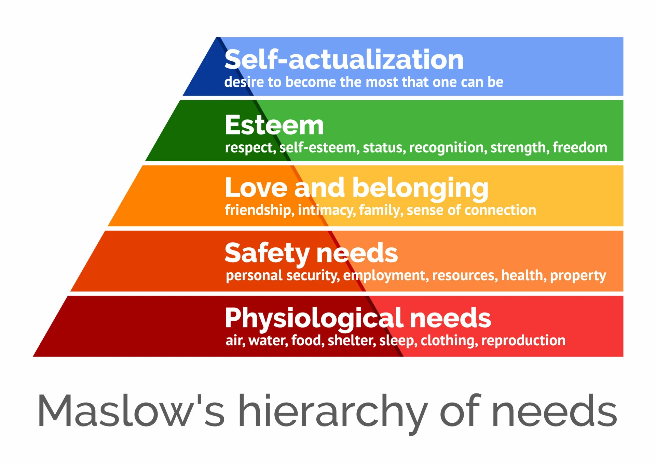
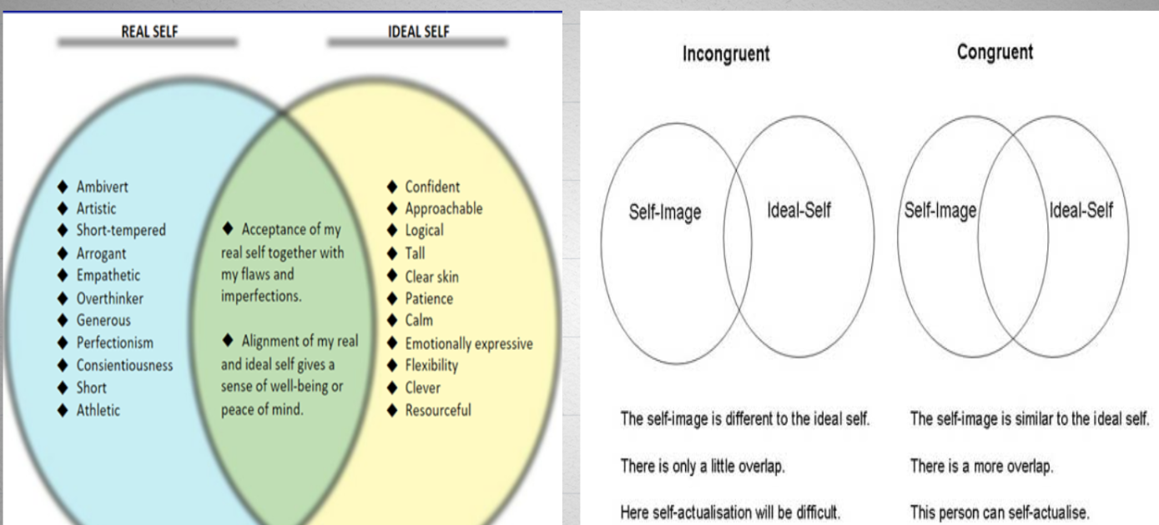
- A healthy self-concept exists when there is congruence between the real self and ideal self.
Trait Theory:
- A stable, enduring quality a person displays in most situations.
- Traits help describe personality and predict patterns of thinking, feeling, and behavior.
- They provide a way to measure how individuals differ from one another.
- Key assumption: Personality traits exist on a continuum, rather than in distinct categories (e.g., extraversion vs. introversion is a spectrum).
Big Five Traits (OCEAN): Personality can be sufficiently described using these
Trait | Description | Key Characteristics | Examples
Openness | Creativity and a desire for new experiences. | Imagination, insight, curiosity, openness to new ideas and experiences. | A person who enjoys trying new hobbies, exploring different cultures, and often has unconventional ideas.
Conscientiousness | Organized, responsible, and goal-oriented. | Thoughtfulness, impulse control, goal-directed behaviors, attention to detail. | A person who plans their day in advance, meets deadlines, and follows through with commitments.
Extraversion | Sociability, energy, and enthusiasm for social interactions. | Excitability, sociability, talkativeness, assertiveness, emotional expressiveness. | A person who enjoys attending parties, initiates conversations, and feels energized in social settings.
Agreeableness | Cooperative and compassionate nature. | Trust, altruism, kindness, willingness to conform to group norms, affection, prosocial behaviors. | Someone who is always willing to help others, listens actively, and gets along well with friends and coworkers.
Neuroticism | Tendency to experience negative emotions. | Anxiety, emotional instability, moodiness, irritability, sadness. | Someone who often worries about things outside of their control, becomes stressed easily, and experiences frequent mood swings.
Personality and Success: Personality traits predict performance in both school and work.
- Conscientiousness is the strongest predictor of better grades in school.
- At work, job performance and success are linked to personality traits such as extraversion, low neuroticism, low agreeableness, and conscientiousness. These traits measured in adolescence can predict employment and job status 46 years later.
Personality and Relationships: Personality influences the quality of romantic relationships and the likelihood of divorce.
- Traits associated with higher divorce rates include high neuroticism, low agreeableness, and low conscientiousness.
- People with low neuroticism, high agreeableness, and high conscientiousness tend to have more satisfying relationships.

ABNORMAL PSYCHOLOGY
Definition – Mental Health (WHO): “Mental health is a state of well-being in which an individual realizes his or her own abilities, can cope with the normal stresses of life, can work productively, and is able to make a contribution to his or her community.”
Abnormal Psychology: A Branch of psychology that deals with abnormal/pathological mental processes and behaviors.
The 4 Ds for distinguishing between Normal vs Abnormal:
- Deviation from Social Norms: Behavior that is significantly different from what society considers normal.
  - Example: Hearing voices, talking to oneself in public without cause, engaging in extreme rituals
- Distress (Personal Discomfort): Behavior is abnormal if it causes anxiety, personal distress, guilt, or harm.
  - Example: Compulsive handwashing due to obsessive thoughts (OCD), overwhelming anxiety when leaving the house (panic disorder), intense sadness and hopelessness lasting for weeks (depression), constant self-criticism and guilt without cause.
- Dysfunctioning: Impairment in daily functioning (work, relationships, etc.)
  - Example: Neglecting personal hygiene due to depression, missing work or being fired due to alcohol or drug use (substance use disorder), withdrawing completely from social or family interactions, being unable to complete academic tasks due to severe anxiety.
- Danger: Behavior poses risk to self or others.
  - Example: Threatening neighbors due to paranoid delusions, talking about suicide and giving away belongings (suicidal ideation), sudden violent outbursts during a manic episode, reckless behavior like driving at high speed through traffic without concern.
Factors Contributing to Mental Disorders:
- Biological: Neurochemicals, neurotransmitters, hormones, brain structure, nervous system
- Psychological: Cognitions, emotions, personality, coping styles, resilience, values
- Social: Social support, family relations, friends, interpersonal factors, love, affiliation
DSM – Diagnostic and Statistical Manual of Mental Disorders
- Published by the American Psychiatric Association
- Describes symptoms and classifies disorders
- Does not explain causes or cures
Major Classifications of Mental Disorders
- Neurotic Disorders: Distressing, but still allows functioning and rational thinking.
  - Examples: Generalized Anxiety Disorder, Depression, Obsessive Compulsive Disorder, Social Phobia, Post-Traumatic Stress Disorder, Panic Disorder, Antisocial Personality Disorder
- Psychotic Disorders: Severe disorders with loss of contact with reality and distorted perceptions.
  - Examples: Schizophrenia, Brief Psychotic Disorder, Delusional Disorder, Substance-induced Psychotic Disorder
Common Psychological Disorders (According to DSM-5)
- Major Depressive Disorder (Depression)
  - A persistent depressed mood or loss of interest in activities.
  - Symptoms: Low mood most of the day nearly every day, loss of interest or pleasure in activities, sleep disturbances, significant weight loss or gain, changes in appetite, fatigue or loss of energy, feelings of excessive guilt or low self-worth, hopelessness about the future, poor concentration, indecisiveness, thoughts of dying or suicide
  - Impact: Causes distress or impairment in social, occupational, or other important areas of functioning
- Panic Disorder
  - Sudden and repeated panic attacks, often without a clear trigger.
  - Symptoms: Overwhelming anxiety or fear, trembling, tingling, rapid heartbeat, feelings of losing control, fear of heart attack or death, intense worry about future attacks, avoidance of places associated with past attacks
  - Difference: Unlike phobias, panic disorder doesn’t require identifiable stimuli
  - Note: Not all who experience panic attacks develop panic disorder
- Schizophrenia
  - A severe psychotic disorder affecting thoughts, feelings, and behaviors.
  - Symptoms: Hallucinations, delusions, disorganized thinking, disorganized or catatonic behavior, social withdrawal, severe impairment in functioning
  - Example behaviors: Talking to imaginary figures, believing in conspiracies without evidence, emotional blunting
- Obsessive Compulsive Disorder (OCD)
  - Unwanted, intrusive thoughts (obsessions) and repetitive behaviors (compulsions).
  - Obsessions: Persistent, unwanted thoughts, ideas, or images
  - Examples: Fear of contamination, fear of harm coming to loved ones, unwanted taboo thoughts
  - Compulsions: Repetitive behaviors or rituals to neutralize anxiety
  - Examples: Repeatedly checking the stove, excessive hand washing, counting, repeating words silently, rituals
  - Cycle: Obsessive thought → anxiety → compulsive behaviour → temporary relief
  - Impact: Behaviors take more than 1 hour/day, cause distress, impair functioning
  - Awareness: Many with OCD know their thoughts are unrealistic, yet struggle to stop behaviors
- Bipolar Disorder
  - Characterized by extreme mood swings between depression and mania.
  - Depressive Episode: Sadness, hopelessness, low energy
  - Manic Episode: Elevated mood, overactivity, delusions, risky behavior
  - Symptoms: Sleep disturbance, racing thoughts, distractibility, inflated self-esteem, impulsive decisions
  - Impact: Affects sleep, energy, thinking, and social relationships
- Internet Gaming Disorder (IGD)
  - Recognized as a condition requiring further research in DSM-5-TR.
  - Symptoms (need 5+ within 1 year): Preoccupation with gaming, withdrawal symptoms (sadness, anxiety, irritability), increased tolerance, unsuccessful attempts to reduce or stop gaming, loss of interest in other activities, continued gaming despite problems, deceiving others about gaming time, using gaming to relieve negative mood, risking job/relationships due to gaming
  - Note: Limited to gaming; does not include general internet, social media, or gambling
- Caffeine Use Disorder
  - Listed in DSM-5 under conditions for further research.
  - Related Conditions: Caffeine intoxication (e.g., restlessness, insomnia), caffeine withdrawal (e.g., headache, irritability)
  - Uncertainty: Not yet confirmed as a clinically significant disorder
- Attention-Deficit/Hyperactivity Disorder (ADHD)
  - A neurodevelopmental disorder with persistent inattention and/or hyperactivity-impulsivity.
  - Inattention: Difficulty staying on task, disorganized, forgetful
  - Hyperactivity: Fidgeting, restlessness, excessive talking
  - Impulsivity: Interrupting others, acting without thinking, trouble delaying gratification
  - Impact: Interferes with academic, social, or occupational functioning
Treatment of Psychological Disorders
- Psychological Approach: Involves therapy by professionals to improve thoughts, behaviors, emotions.
Types: Psychoanalysis, humanistic therapy, cognitive behavioral therapy (CBT), and others
- Biomedical Approach: Treats biological causes of disorders.
Methods: Medication (antidepressants, antipsychotics), electroconvulsive therapy (ECT), transcranial magnetic stimulation (TMS), psychosurgery
- Social Approach: Focuses on improving the individual's social environment.
Methods: Group therapy, couple/family therapy, community outreach
Strength: Also emphasizes prevention, not just treatment (recommended by WHO)

ADDICTION

Definition of Addiction
Addiction is a complex condition characterized by the repeated use of a substance or behavior despite negative consequences. It includes a craving or compulsion to continue use even when it causes harm.
Types: what the person is addicted to
- Substance Use Disorders: Alcohol, drugs, nicotine.
- Behavioral Addictions: Gambling, internet, gaming.

Categories of Addiction: nature of addiction
- Chemical Addiction: Involves substance use.
  - Examples: Alcohol Use Disorder, Drug Use Disorder (e.g., cocaine, heroin), Nicotine Use Disorder.
- Non-Chemical Addiction: Involves compulsive behaviors.
  - Examples: Gambling, food, risky sex, internet, shopping.

Common Symptoms of Drug Addiction
- Tolerance: Needing more of the drug to get the same effect.
  - Example: Someone who once needed one drink now needs three to feel relaxed.
- Withdrawal: Physical or psychological symptoms when stopping use.
  - Example: Nausea, irritability, shaking after quitting smoking.
- Loss of Control: Using more than planned or being unable to stop.
  - Example: Saying “just one” and ending up bingeing.
- Life Revolves Around Drug Use: Spending significant time using, seeking, or recovering from drugs.
  - Example: Missing work or family events due to hangovers or drug hunts.
- Abandonment of Enjoyable Activities: Giving up hobbies, sports, or social time for drug use.
  - Example: Quitting soccer or avoiding friends to stay home and get high.
- Continued Use Despite Harm: Ongoing use despite health, legal, or social problems.
  - Example: Continuing to drink heavily after a DUI or liver warning.
- Neglecting responsibilities: Giving up important social, occupational, or recreational activities because of substance use

Substance Addiction & Brain Function
- Substance addiction is a neuropsychiatric disorder where a person persistently uses a drug despite harmful consequences, influenced by repeated exposure, genetics, and psychological and social factors.
- Dopamine Role: Dopamine is a neurotransmitter crucial for reward, motivation, and pleasure, and while healthy activities release it in a balanced way, addictive drugs and behaviors hijack this system by triggering intense, prolonged dopamine release and blocking its reabsorption, which disrupts natural brain function and leads to long-term changes that make normal activities less rewarding.
- Examples: Cocaine and heroin block dopamine reabsorption, intensifying addiction.

Stages of Drug Addiction
- Experimentation: Voluntary use without major consequences.
- Regular Use: Increased risk, may not lead to addiction.
- Risky Use/Abuse: Continued use despite legal/social problems.
- Addiction/Dependence: Compulsive use, withdrawal symptoms, life disruption.

Causes of Addiction
- Biological: Genetics (40–60% influence), family history.
- Psychological: impulsivity, sensation seeking, trauma, and underlying mental health conditions like depression or anxiety can significantly increase the risk of developing addiction.
- Environmental: Family dysfunction, abuse, substance accessibility, peer pressure, cultural influences, and poor coping skills all contribute significantly to the risk of addiction.

Drug Categories and Examples
- Stimulants: Increase CNS activity.
  - Examples: Cocaine, meth.
  - Effects: Alertness, euphoria; Side effects: weight loss, psychosis, stroke, organ failure.
- Depressants: Slow CNS activity.
  - Examples: Alcohol, sedatives.
  - Effects: Calmness, drowsiness; Side effects: respiratory issues, coma, lung cancer, memory problems, slurred speech, and poor coordination
- Hallucinogens: Substances that profoundly alter perception, thoughts, and feelings, often producing intense sensory distortions or "trips."
  - Examples: LSD, psilocybin.
  - Effects: Sensory distortion ("trips"); can be pleasant or frightening, euphoric, paranoia; Side Effects: sweating, dehydration, psychosis, flashbacks, depression.

Reward System & Addiction Cycle
- Pathway: Ventral tegmental area → Nucleus accumbens → Frontal cortex.
Cycle
- Initial use: Drug or behavior triggers reward system, releasing dopamine.
- Tolerance: Repeated use demands more for the same effect.
- Withdrawal: Reducing or stopping use causes discomfort and anxiety.
- Craving: Dopamine-driven urges fuel continued use.
- Relapse: The cycle repeats, reinforcing addiction.

Consequences of Drug Use
- Crime, job loss, death, relationship failure, educational decline, death.

Addiction Treatment
- Addiction is treatable, but not curable in a few days.
- Requires long-term, multi-component interventions.
- Focus: stop drug use, restore functioning, prevent relapse.
To prevent drug abuse:
- Stay informed about the risks of substance abuse
- Engage in alternative activities
- Build self-confidence
- Make positive future plans
- Be brave enough to say “NO!”
- Surround yourself with friends who disapprove of drug use
- Address underlying issues
- Seek professional help when needed.

Non-Substance Addiction

Definition: Addiction to behaviors without substance use, often called behavioral addictions.
Examples: gambling, food, shopping, internet/social media, pornography, gaming, risky sexual behavior, and cosmetic surgery.

Symptoms: Symptoms of non-substance addiction include compulsive and repetitive behavior, inability to stop or control the activity, impaired judgment, intense cravings, strained relationships, inappropriate emotional responses, and failure to recognize harmful consequences.
For example, a person addicted to gambling may spend all his or her savings.

Cause & Diagnosis
- Cause: Same brain reward system as substance addiction.
- Diagnosis: Self-recognition, family observation, or clinical assessment by a mental health professional.

Lecture 10: Leadership
Leadership is the process of influencing people and creating an environment to achieve team or organizational goals.
Leadership involves: Vision, followership, and influence
Example: A startup founder (vision), inspires team (followership), and drives actions (influence).

Qualities of a Good Leader:
Shared Vision, lead change, inspire people, honest, set example, empower people, forward-looking, competent
Example: A class rep encourages student participation, delegates tasks, and listens to concerns respectfully.

Trait Theory of Leadership
- Definition: Leadership is based on inborn traits; leaders are born, not made.
- Core Idea: People with specific traits are naturally better leaders.
- Common Traits: Confidence, honesty, intelligence, determination, good communication skills.
- Implication: Leadership potential is innate, not situational or trainable.
- Examples:
  - A student naturally organizes group tasks, communicates clearly, and resolves conflicts without being told.

Situational Leadership Theory
- Definition: Effective leadership style varies by situation; leaders must adapt based on followers’ readiness.
- Core Idea: No one-size-fits-all; leadership changes depending on task, team maturity, motivation, and skill.
- Adaptation Examples:
  - New/unskilled teams: Leader gives clear directions, step-by-step guidance.
Example: A call center manager training new hires with scripts and instructions.
  - Skilled/confident teams: Leader gives freedom, support, and autonomy.
Example: A senior software team is trusted to design and deliver with minimal supervision.
- Implication: Leaders need to observe team capability, then switch between directive, coaching, supporting, or delegating styles.
- Real-World Example: Sports Coaches: Provide strict guidance for rookies, but strategic freedom for veteran players.

Transformational Leadership Theory
- Definition: A transformational leader inspires, motivates, and elevates followers by focusing on their personal growth, not just task execution.
- Core Traits:
  - Visionary: Shares a compelling future path.
Example: Elon Musk inspiring belief in space travel and sustainable energy.
  - Trust-Building: Forms deep, respectful relationships.
Example: Manager holds regular check-ins and supports team goals.
  - Creative Encouragement: Promotes innovation and openness.
Example: Coding club leader lets members choose and develop their own projects.
  - Growth-Oriented: Helps followers become better people, not just better workers.
Example: Senior student mentors juniors on leadership and public speaking.
- Implication: Leaders are change agents, turning followers into high-performing, purpose-driven individuals.

Leadership Styles Based on Authority

A. Autocratic / Authoritarian Leadership
- Definition: Leader holds all decision-making power, gives orders without consulting the team, expects full compliance. Subordinates' suggestions or initiatives are not entertained. The leader decides for the group and shares decisions only when necessary.
- Key Traits: Centralized control, limited input, fast execution, top-down communication.
- Advantages: Quick decisions, clarity of command, confidential matters are secure, works with low-skill teams.
  - Example: Military command in crisis — one leader gives direct orders.
- Disadvantages: Subordinates uninformed about reasons, forced compliance, loss of creative input, high dependency on leader’s efficiency, threatens organizational continuity, team demotivation, poor morale.
  - Example: Old-style factory management — no team feedback or innovation.

B. Democratic Leadership (Consultative & Persuasive)
- Definition: Leader involves team in decision-making (consultative), or makes decisions and persuades team (persuasive).
- Key Traits: Shared decision-making, participation, collaboration, mutual respect, team empowerment.
- Advantages: Fits most environments, encourages creativity, builds strong teams, effective for complex decisions.
  - Example: Modern tech teams brainstorming product features before a sprint.
- Disadvantages: Time-consuming, may delay action, can appear indecisive or overly accommodating, apologetic
  - Example: University committees that consult heavily before implementing changes.

C. Laissez-faire / Free-Rein Leadership
- Definition: Leader gives maximum freedom to the team, avoids direct guidance, relies on team’s expertise and independence.
- Key Traits: Max autonomy, non-interference, trust in team, minimal involvement, low oversight
- Advantages: Works well with skilled experts, supports independence, promotes innovation.
  - Example: Research labs where scientists manage their own work.
- Disadvantages: Lack of role awareness, poor group involvement, low accountability, passive leadership, risk of avoidance.
  - Example: Failing startup where the leader is too hands-off, leading to confusion.

Recipe for Being a Leader - Core Actions for Leadership Success:
- Take control of your life
- Own responsibility for who you are
- Show a positive, dynamic attitude consistently
- Accept blame for mistakes, learn from them
- Take accountability for your team’s performance
- Give credit to others when due
- Be compassionate when evaluating progress or failure
Examples:
- Satya Nadella: Took accountability during Microsoft’s shift, credited teams, fostered growth.
- Howard Schultz (Starbucks): Owned business responsibility, uplifted baristas, gave team credit.

Lecture 2: Research Methodology in Psychology

What is Research?
- Systematic Inquiry: Follows a structured approach.
- Knowledge Expansion: Develops new insights & confirms theories.
- Problem-Solving: Addresses specific issues.

Types of Research
- Basic Research: Expands theoretical knowledge (e.g., studying how memory works).
- Applied Research: Solves specific problems (e.g., developing new teaching strategies).

Scientific Process
- Observation → Identify patterns.
- Hypothesis → Testable prediction (e.g., students who sleep more score higher).
- Experiment Design: Define variables.
  - Independent Variable (IV): Manipulated (e.g., study hours).
  - Dependent Variable (DV): Measured outcome (e.g., test score).
  - Control Variables: Factors kept constant.
- Conducting the Experiment: Execution & data collection.
- Analyzing Data: Statistical & qualitative interpretation.
- Drawing Conclusions: Support or reject hypothesis.
- Reporting Results: Publish findings & peer review.

Research Process
- Identifying a Problem – Define a clear research question.
- Literature Review – Review existing research & refine questions.
- Study Design – Select methodology (qualitative, quantitative, mixed).
- Data Collection – Gathering information (surveys, experiments, interviews).
- Data Analysis – Using statistical or qualitative methods.
- Reporting Findings – Structured presentation of results & implications.

Research Methodologies
- Qualitative Research: Subjective, descriptive (e.g., interviews, case studies).
- Quantitative Research: Statistical, numerical (e.g., experiments, surveys).
- Mixed Methods: Combination of qualitative & quantitative approaches.

Ethical Considerations
- Informed Consent: Participants voluntarily agree.
- Confidentiality: Privacy protection.
- Integrity: No data fabrication.

Applications of Research
- Academic: Expands knowledge in psychology & science.
- Professional: Informs policy & practice (e.g., healthcare, education).

Lecture 3: Learning

Definition:
Learning = Permanent change in behavior due to experience.
- Stimulus: An event/object triggering a response.
- Response: Reaction to the stimulus.

Types of Learning

1. Classical Conditioning (Pavlov) – Learning via association
- Before Conditioning: UCS (Food) → UCR (Salivation).
- During Conditioning: NS (Bell) + UCS (Food) → UCR (Salivation).
- After Conditioning: CS (Bell) → CR (Salivation).
Example: Pavlov’s Dog Experiment.

2. Operant Conditioning (Skinner) – Learning through consequences/associations
- Reinforcement (Increases behavior)
  - Positive Reinforcement: Adding a reward (e.g., praise for good grades).
  - Negative Reinforcement: Removing something unpleasant (e.g., no homework for good behavior).
- Punishment (Decreases behavior)
  - Positive Punishment: Adding an unpleasant consequence (e.g., scolding).
  - Negative Punishment: Removing a desired object (e.g., confiscating a phone).
Example: Skinner Box – Rats press a lever for food.

3. Observational Learning (Bandura) – Learning by watching others
- Modeling: Imitating observed behaviors.
- Bobo Doll Experiment (1961): Children copied adult aggression toward a toy.
Example: A child avoids jumping on a table after seeing their sibling get scolded.

Reinforcements & Punishments (Examples)
- Reinforcements: Praise, rewards, extra privileges.
- Punishments: Scolding, isolation, loss of privileges.

